Guide to PYCOM IOT device

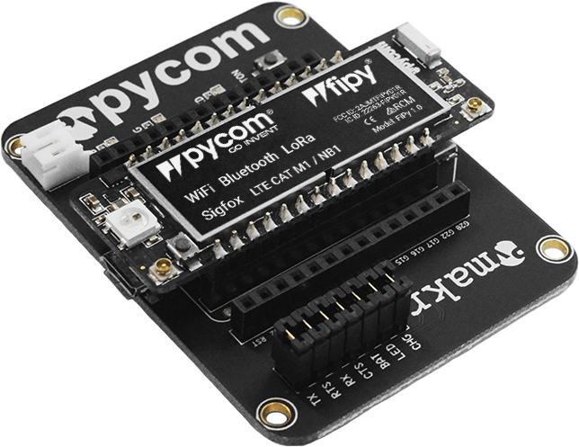



# Overview

The EDA acquired two PyCom module for exploration of possible use for remote data/status logging of Lemi devices in the field. The concept was tested by pushing data from the PyCom module through the Sigfox network to a server running at Hermanus and then displayed on a Grafana dashboard.

To access data over the Sigfox network, callbacks was configured for each device. For the test unit, an email callback was configured that sent all the status information as well as the full data field with an email to the SANSA EDA test email account. This email was then retrieved with a python script and posted to an IncluxDB database on the Influx PC.

# Installation of Pycom Pymakr within Atom.

To do the development Pycom PYMAKR package for Atom was used. (Alternative options are available like using WinSCP)

## Install Atom

<https://atom.io/>

**Note**: The following versions of the software was used as that the latest version at the time was not working. The latest version should be working.

<https://github.com/atom/atom/releases/tag/v1.19.4>

## Install Pymakr package

The Pymakr package can be installed from within the Atom packages manager.

**Note:** At the time of when I did the installation on my PC there were a bug in the latest Pymakr package, preventing full installation, this will most likely not be the case anymore but the instructions I followed to install an older version is listed in item 2.2.1

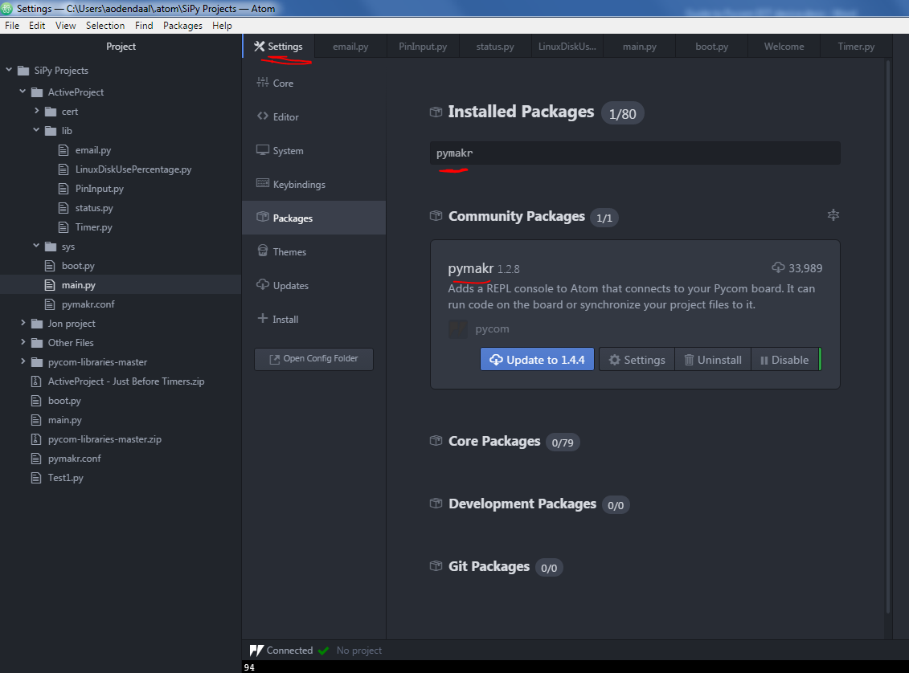

### Manual install (pymakr-atom-1.2.8)

To manually install the plugin, follow these steps

•Delete any existing installation of the plugin

•Download the code from github

•Override all files in the ~/.atom/packages/**pymakr** folder

•If you haven't installed Pymakr before, place the files in any folder and run apm link

•Run the commands apm install (Within the pymakr forlder in CMD) (or npm install if apm is not available) from package folder

•Restart atom

# Importing data from email into InfluxDB database

The data sent by the PyCom module can be retrieved and posted to an InfluxDB database with the script located in the home folder:

/home/influx/airflow/lib/python2.7/site-packages/ PyComDeviceStatusImport.py

# Accessing the web portal

To configure the Sigfox callbacks you need to log into the sigfox backend web portal. Login credentials can be obtained from the EDA Manager, as the modules is on his profile.

<https://backend.sigfox.com/auth/login>

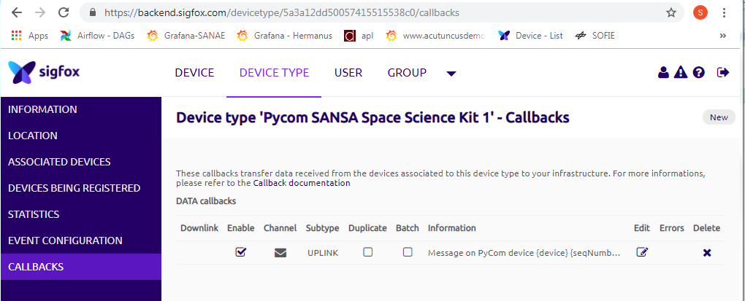

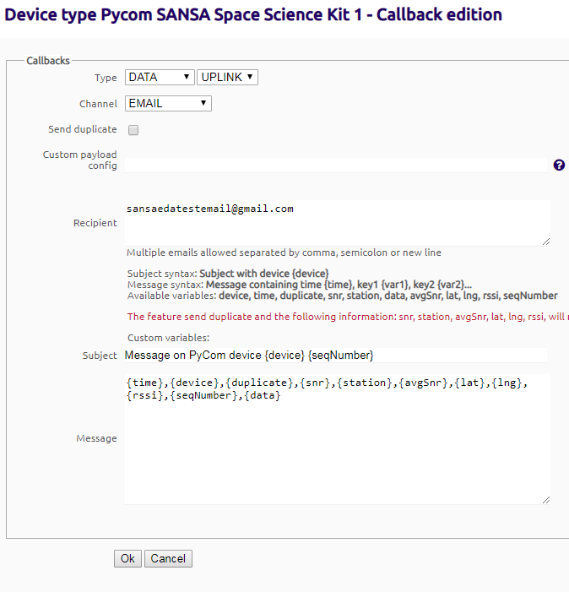

# Email Account details

The EDA test email account can be assessed at Gmail account:

sansaedatestemail@gmail.com

5ansaeda

# Programming the Pycom module

## Connecting with the module

To connect to the module a USB to Micro USB cable is needed, the Pymakr base board has a USB to Serial converter which should install on your PC when connected. The serial port settings are important and can be found by assessing the More tab > Get serial ports and then reading the COM port number from the terminal as indicated below.

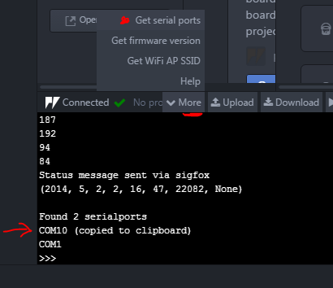

This port setting needs to be applied in the Pymakr settings page, which can be found in the under Settings > Packages > Pymakr > Settings > COM Port

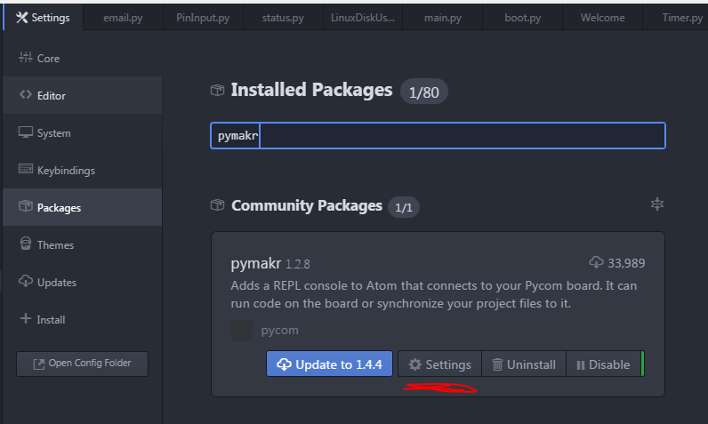

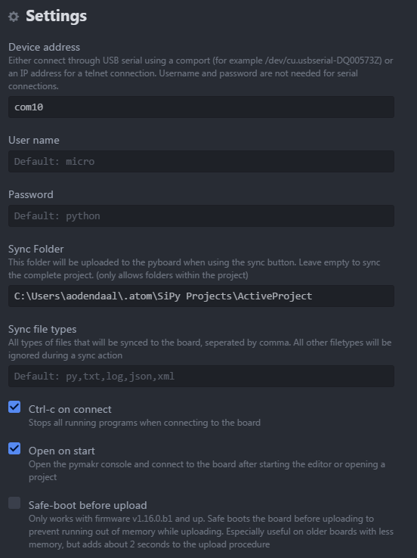

The username and password were left as default (micro; python)

Lastly the setting needs to be applied in the configuration file as well:

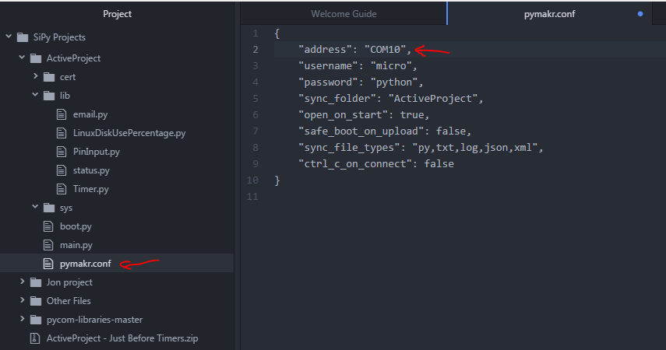

You should now be able to connect:

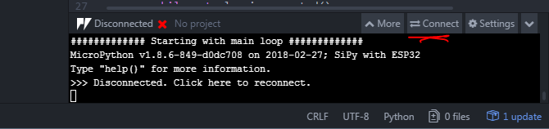

When connected you should be able to run python commands through the terminal:

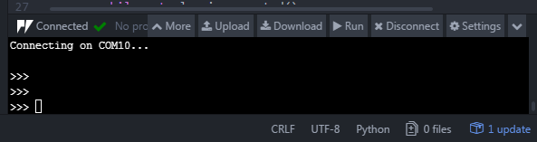

## Software structure

The Pycom module contains an active project directory in which the python project code of the module is saved. As standard there is a boot.py, which runs at bootup, a main.py, which is the main python script that runs after bootup on the module and then the pymakr.conf file which contains the settings of the module.

In addition to the 3 default files, there is a library folder containing all the custom Python libraries developed for the application. Currently in use are the email.py and PinInput.py. The status.py, LinuxDiskUsePercentage.py and Timer.py are all experimental development scripts.

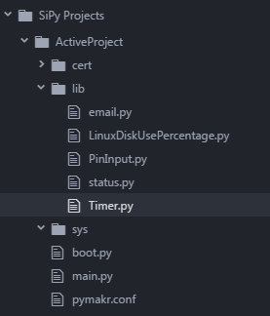

To synchronise the project files located on you PC with the ones on the module press CTRL + ALT + S.

# Documentation and guides can be found here:

It is recommended that you familiarise yourself with the online documentation for the Pycom devices:

<https://docs.pycom.io/>